Hello friend,

I have received the first feedback from my professor FOR THE ESSAY PAPER#2 AND NOT SHORT WRITING ASSINGMENT, and it is kind of bad news. He said that you needed to start again from the beginning because overall was not what the prompts asked you to do. He said that it was more wasting time and effort to revise them because every paragraph was more like a summary. The reasons are:

- The prompt asks you to analyze the significance of wars (WW2 is too broad); can you explain about Vietnam war in the revision? Your latest work was more like a summary of the class material. Each paragraph has to start with a strong thesis based on your argument in analyzing the significance of war and how it has shaped or impacted the particular Asian ethnic group experiences. There is also material about Vietnam on the PowerPoint slide on Canvas. Please read it.
- It has to be a specific group. For example, you only talk about Vietnamese.
- In each paragraph, your paper MUST consist of a clear/ strong thesis, supported by your own reasons, and backed up by evidence drawn MINIMUM ONE from the reading. For illustration, you give a strong thesis on your analysis of the significance of the Vietnam War toward the Vietnamese. For example, what happens before and after this war, and what are the impacts for them. Then each paragraph, you tell your reason. Also, in each paragraph, there must be a least one supporting evidence from the course reading. For most of your paragraph, there is no evidence at all. Please remember that the evidence is drawn from at least THREE different readings.
- Also, your paragraph was too short. Each paragraph has to have a strong main thesis, your reason, and the evidence from the book.
- Some of your formattings were wrong. Please see the WRITING GUIDELINES.
- You have to remember that this paper aims to persuade readers to think differently based on your own argument or perspective on the prompt. Not summarize. You have to emphasize what do you think about it more.
- THINK OF YOUR ESSAY WHICH YOU SEEK TO PERSUADE OR CONVINCE YOUR READER BASED ON YOUR PERSPECTIVE.

Please read the instructions carefully.

Please read:

THE PAPER IS GRADED ON HOW YOU UNDERSTAND THE MATERIAL’S CONCEPT TO CONVINCE YOUR PERSPECTIVE TO THE READERS BASED ON THE PROMPT. MY PROFESSOR WANTS TO KNOW WHETHER YOU HAVE COMPREHEND THE MATERIALS’S CONCEPTS OR NOT AND HE GRADED IT BASED ON THAT WAY. IT IS NOT GRADED BASED HOW WELL YOU DO THE SUMMARY; IT IS NOT WHAT THE PROMPT ASKS. THEREFORE, THERE IS NO CORRECT OR WRONG ANSWER. YOU HAVE TO BE MORE CRITICAL IN DOING THIS. THANK YOU!

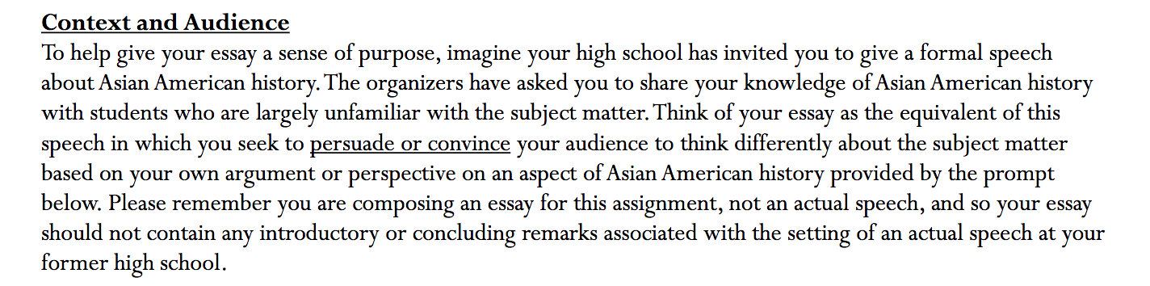
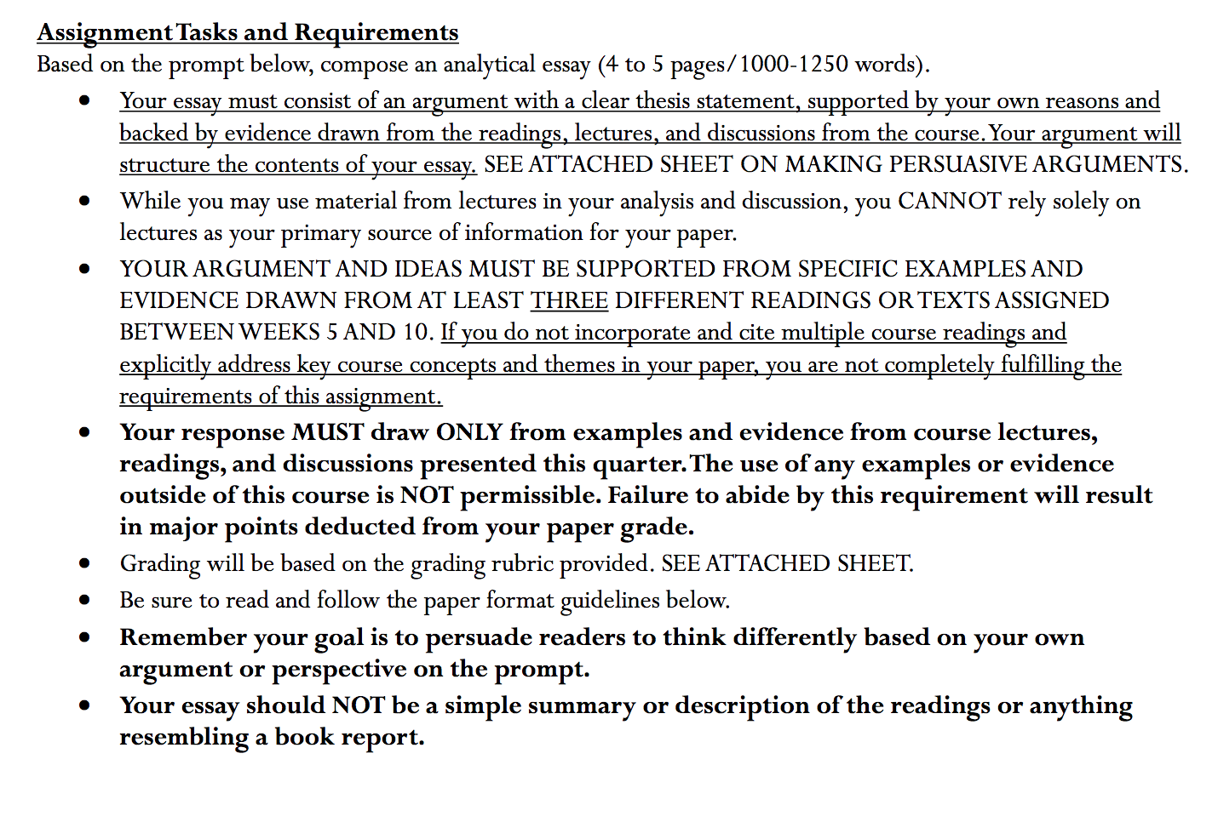
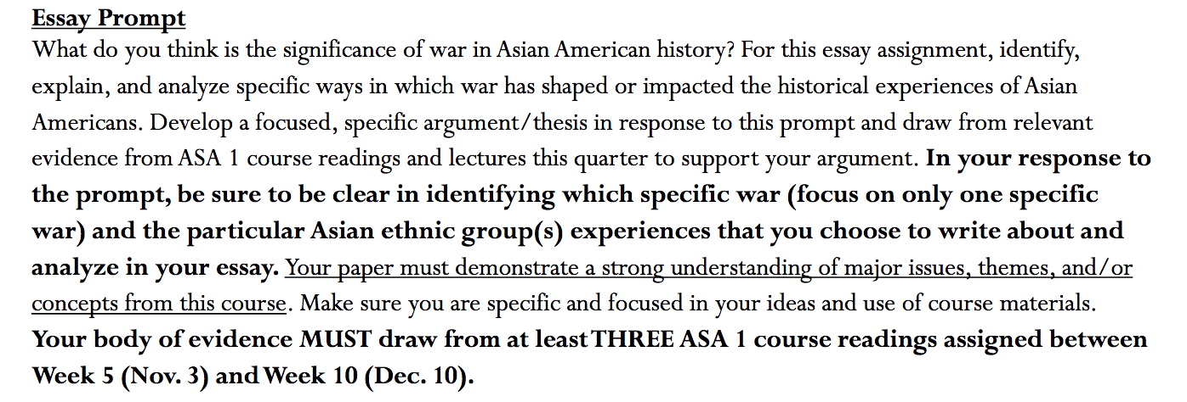

You are NOT SUMMARIZING. THIS IS AN ARGUMENTATIVE PAPER, WHERE YOU GIVE YOUR ARGUMENT AND CLEAR THESIS BASED ON THREE DIFFERENT COURSE READINGS. PLEASE READ!
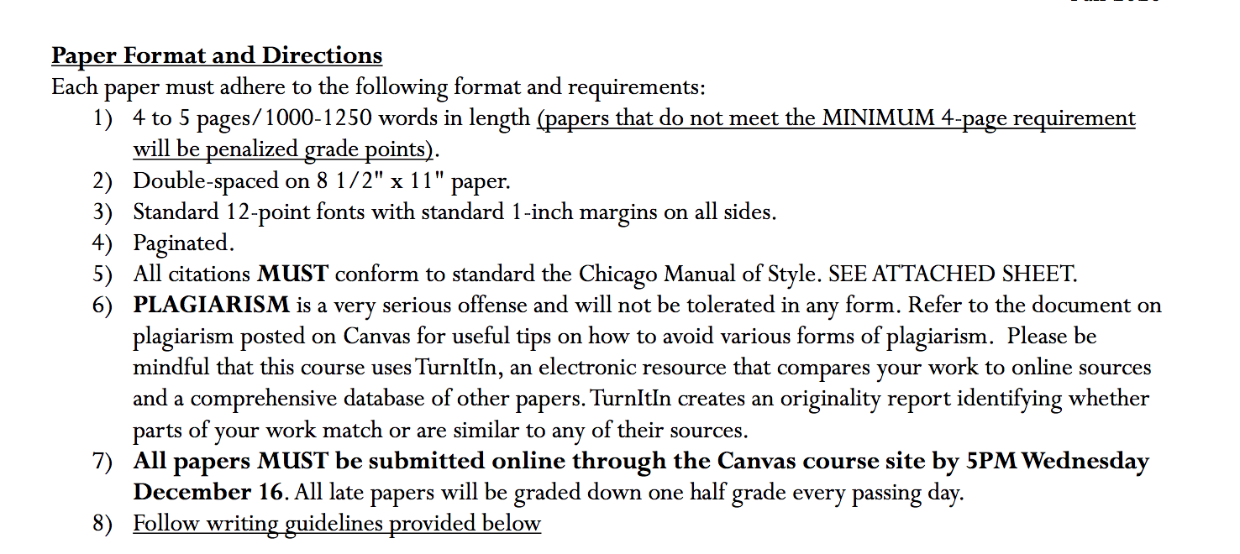

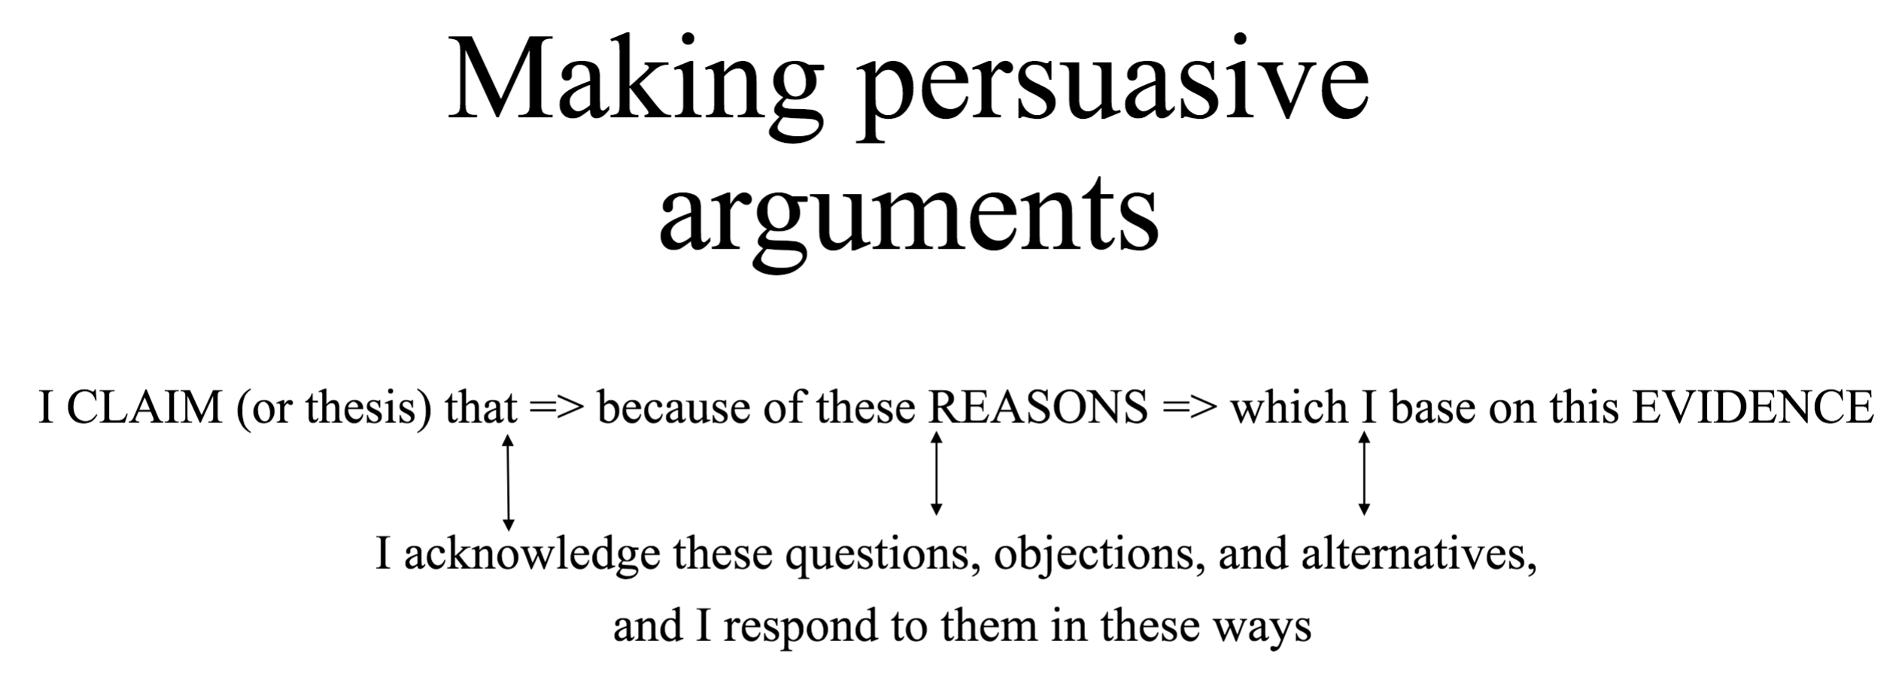

Your body of evidence must draw from at least THREE course reading assigned below!

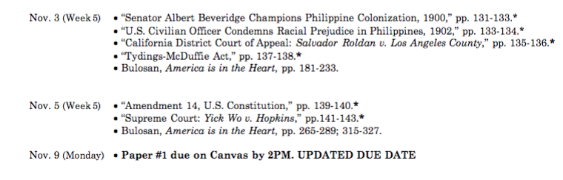

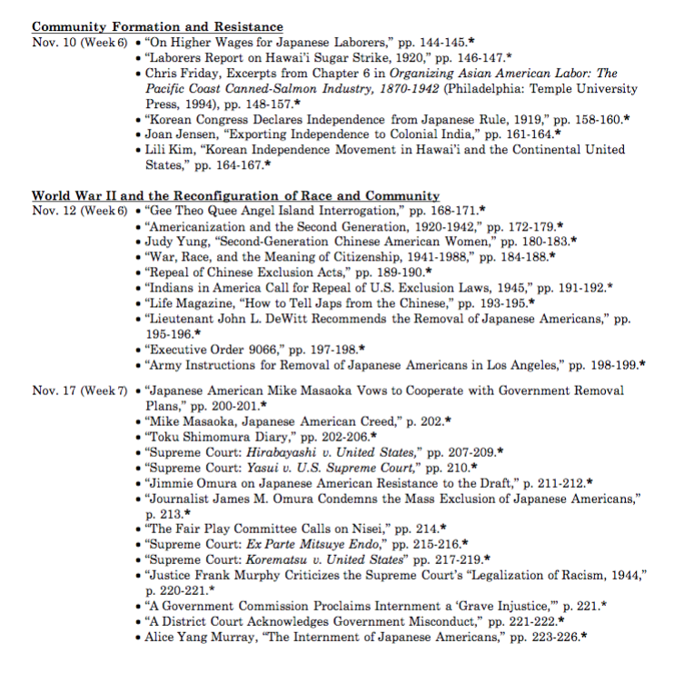

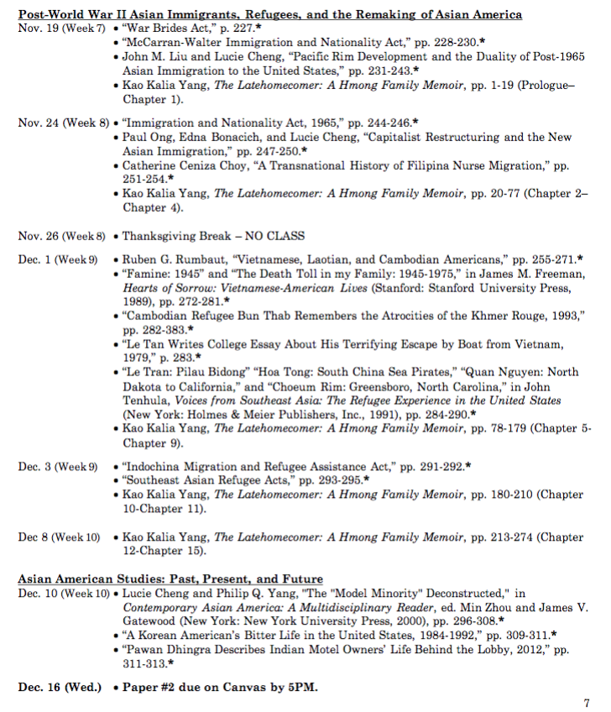

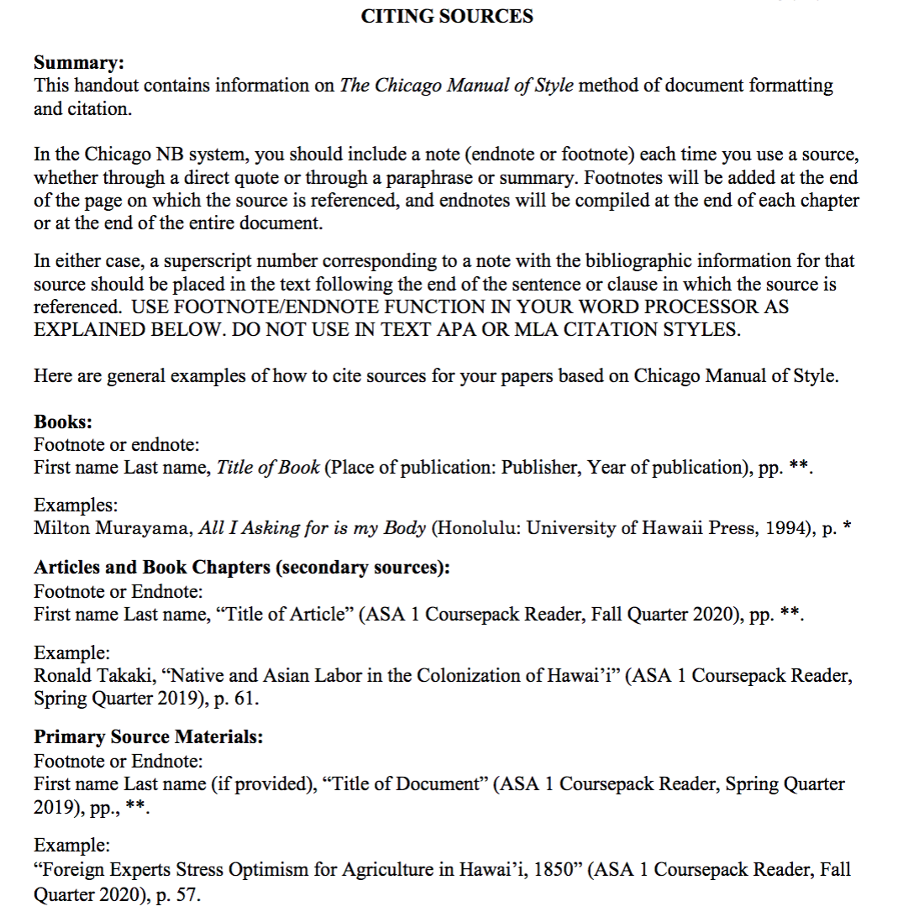

My Prof’s feedback:
“I skimmed through your paper and it seems like you are writing about the effects of the war on Vietnam, not necessarily about the significance of war in Asian American History. There is a lot of summary about the events that occured but not enough analysis. I think you can have a stronger analysis on how your evidence is tied to the significance of war in Asian American History.

If I were you, I would focus on revising to have less description of examples and more analysis. Organize the paper so that the reader knows exactly what your argument is at the very beginning of the paper, within the first paragraph. Do not organize your paper according to the readings you are using, but rather by the larger themes of your argument."

In every paragraph, begin the paragraph with a clear topic sentence. EACH PARAGRAPH SHOULD ONLY EXPLORE ONE POINT. Then, you tell your reason/ analysis your reason, then backed it up with at least one piece of evidence from the reading. The reading purpose’s just to support your argument by telling the evidence. Please do not need to summarize the reading or telling what happens in the reading. Instead, you suppose to give analysis or argument about the prompt and show that the reading also supports your argument. For illustration, you give a strong thesis on your analysis of the significance of the Vietnam War toward the Vietnamese in economics side. For example, what happens before and after this war, and what are the impacts for them in economics side, then what is your reason, and how your reason is backed up in the reading. This is graded on how you able to convince/ persuade your readers about your analysis toward the prompt. Your latest work was more like a summary of the class material. Each paragraph has to start with a strong thesis based on your argument in analyzing the significance of war and how it has shaped or impacted the particular Asian ethnic group experiences.
Note: You have to remember that this paper aims to persuade readers to think differently based on your own argument or perspective on the prompt. Not summarize. You have to emphasize what do you think about it more. THINK OF YOUR ESSAY WHICH YOU SEEK TO PERSUADE OR CONVINCE YOUR READER BASED ON YOUR PERSPECTIVE.

You always summarize the reading. The reading purpose’s just to support your argument by telling the evidence. Please do not need to summarize the reading or telling what happens in the reading. Instead, you suppose to give analysis or argument about the prompt and show that the reading also supports your argument. This is graded on how you able to convince/ persuade your arguments to readers about your analysis toward the prompt. This is what the professor called “analysis.”

YOU DO SUMMARY > YOU DO SUMMARY
PLEASE CHANGE THE SENTENCES THAT YOU SUMMARY INTO MORE ANALYSIS OR YOUR ARGUMENT TOWARD IT. DO NOT TELL WHAT HAPPENS IN THE READING.

My recent tutor’s work that is totally wrong because he did summary rather than analysis.

Significance of the Vietnam War to Vietnamese
The Vietnam War is among the Asian wars that are known for their impacts on the Vietnamese. From a personal point of view, I think the war had varied social and economic impacts on the Vietnamese. The war's most immediate effect was the presence of the death toll, which was estimated at 3 million people. In addition, the war led to a significant impact on the Vietnamese society, such as deaths, the killing of the great community, and the destruction of farms and homes, leading to increased refugees' rates, especially among the South Vietnamese. However, the war was significant for the Vietnamese through shaping society. One of the social impacts of the war is that it improved diplomatic relations between the two nations. I claim that the war was significant because it led to the development of effective economic plans to revive the ravaged economy, which translated to economic growth, development of urban cities, change of the US immigration act, which opened doors for the Vietnamese people, the adaptation of the Vietnamese people to American culture, and the development of diplomatic relations between the two nations.
The Vietnam War led to the development of effective plans to revive the ravaged economy of the country (result of Vietnam war not the significant of Vietnam War toward Vietnamese). As a result of the economic suffering caused by the war, there was a need to develop economic plans to help the country recover economically. For example, practical goals (Third-five Year Plan), which were a compromise of the pragmatic and ideological factions, were developed, and they emphasized for the growth of industry and agricultural sectors from 1981 to 1985 ( you do not need to tell what happens in the story, just show that the reason is backed from this reading) (Flora Belle Jan Longs for Unconventionality and Freedom, 1924. ASA 1 Course pack Reader Fall Quarter 2020), pp. 173). Efforts to decentralize the planning and enhance managerial skills for the government officials were implemented. In 1986, Vietnam launched economic and political renewal campaigns, which were intended to improve market socialism and a centrally planned economy. This strategy was to enhance the establishment of personal businesses and foreign investments. Under the establishment of a planned economy, 30,000 private enterprises and agricultural reforms had been developed by the 1990s ( more like summary rather than analysis) (Lucie Cheng and Philip Q. Yang, “The “Model Minority” Deconstructed,” in Contemporary Asian America: A Multidisciplinary Reader, ed. Min Zhou and James V. Gatewood (New York: New York University Press, 2000), pp. 296). By 2001, the 10-year economic plan was established, which has led to the country being included in the Economic Forum Global Competitiveness Report ranks. (please make it to your argument about it, do not write any data or fact)
In addition, the Vietnam War spurred the economic growth of the country. Following the adverse impacts of the war, there was a need for immediate efforts to revive the economy of the country. Initially, French colonization in the mid-19th century had developed the economy of the country even at the village levels. The French colonizers based their manufacturing in the North while agriculture was in the South. After the division of the North and South to communism and capitalism, respectively, different economic ideas were developed. The occurrence of the Vietnam War negatively affected the economy of the country. Therefore, the administration of the country, together with the citizenry, came up with effective and efficient solutions geared towards reclaiming the economic growth of the nation. (summary) The Vietnam War worsened the economy of the country by contributing to the death of many people, some of whom were skilled workers, technicians, intellectuals, and professionals who had immensely contributed to the economic growth of the country. From 1976 to 1986, there was a need for integrations to enhance national income, agriculture, and industries (summary not analysis from you) (John M. Liu and Lucie Cheng, “Pacific Rim Development and the Duality of Post-1965 Asian Immigration to the United States,” pp. 237). However, the plans were not executed, and the economy was dominated by technological shortcomings, unemployment, low production, and small-scale production. (summary not analysis from you)
Besides, the Vietnam War led to the force urbanization of cities in Vietnam, resulting in a significant economic impact on Vietnam society. Forced urbanization was influenced by the bombing of the rural areas, which caused many people to shift from their rural residence to the cities. Shelling and bombing led to increased rates of refugees in several cities, which was later acknowledged as forced urbanization (summary not analysis from you) (John M. Liu and Lucie Cheng, “Pacific Rim Development and the Duality of Post-1965 Asian Immigration to the United States,” pp. 234). The modern practices were initiated first by the French, who did the same in North Africa and Southeast Asia, and strengthened by the Americans, who reinvented everything introduced by the French people. The presence of a planned economy influenced the family, and it was not considered an economic unit anymore. Before modernization, the family played a significant role in the education of its members. However, the modernization caused by the war led to the transfer of educational functions outside society. The rise in education led to increased professionalism that enhanced increased rates of employment, which enhanced economic development in the country. (summary)
Moreover, the Vietnamese people benefited from the USA migration acts, which gave them more opportunities, such as chances to generate wealth. In general, the occurrence of Vietnam War led to increased diversity in the USA. As people migrated to the USA from the war zones, the Immigration act was made flexible in 1965. The immigration laws of 1965 and 1990 presented significant reforms in the USA immigration policy, which benefited the Vietnamese. Also, the Vietnam War contributed mostly to the transformation of the USA immigration policy. Large-scale immigration of the Vietnamese to the USA occurred after the war when Saigon's fall led to US-sponsorship evacuation of 125,000 refugees from the country in1875 (John M. Liu and Lucie Cheng, “Pacific Rim Development and the Duality of Post-1965 Asian Immigration to the United States,” pp. 240). The humanitarian displacement of people in Indochina intensified, and more families were admitted to the USA. This led to the increased number of the Vietnamese population compared to other people. The increased number of Vietnamese contributed to the USA's increased diversity, which led to a restructuring of the policy. (summary)
Also, the Vietnam War improved the relations between the US and Vietnam. After the severe effects of the war, both governments sought to enhance their diplomatic relations. Notably, the then president of the US, Bill Clinton, announced formal plans to normalize diplomatic relations with Vietnam. One of the measures that were taken by the countries was upgrading the Liaison offices to the level of embassy status. As a result, the US established an office in Saigon city of Vietnam, while Vietnam established an embassy representative in San Francisco. Improved diplomatic relations were highly needed for peaceful coexistence between the two nations. Due to the improved diplomatic relations between the two nations, the rate of immigration in both the US and Vietnam improved. For example, in modern times, there are around 1.8 Vietnamese in the United States, including students pursuing their education goals (summary) (Paul Ong, Edna Bonacich, and Lucie Cheng, “Capitalist Restructuring and the New Asian Immigration,” pp. 248).
In conclusion, I think the Vietnam War was essential to the Vietnamese people both socially and economically. Notably, the war led to the development of effective economic plans to revive the ravaged economy, which translated to economic growth, development of urban cities, change of the US immigration act, which opened doors for the Vietnamese people, the adaptation of the Vietnamese people to American culture, and the development of diplomatic relations between the two nations. As the administration and the civilians were striving to survive after the war, there was the development of plans which enhanced economic growth in the country that has benefited the society up to date.

PLEASE READ THE FIRST PAGE OF MY EXPLANATION

Bibliography
Chan, Sucheng. Chapter 5. "Immigration and Nationality Act, October 3, 1965". Asian American: An Interpretive History. Twayne Publishers, 1991. 247-256
Flora Belle Jan Longs for Unconventionality and Freedom, 1924. ASA 1 Course pack Reader Fall Quarter 2020), pp. 173-174.
Miguel, Edward, and Gerard Roland. "The long-run impact of bombing Vietnam." Journal of Development Economics 96, no. 1 (2011): 1-15.
Lucie Cheng and Philip Q. Yang, “The “Model Minority” Deconstructed,” in Contemporary Asian America: A Multidisciplinary Reader, ed. Min Zhou and James V. Gatewood (New York: New York University Press, 2000), pp. 296-308.
Pholsena, Vatthana. "The (transformative) impacts of the Vietnam War and the Communist Revolution in a border region in Southeastern Laos." war & society 31, no. 2 (2012): 163-183.
John M. Liu and Lucie Cheng, “Pacific Rim Development and the Duality of Post-1965 Asian Immigration to the United States,” pp. 231-243.
Paul Ong, Edna Bonacich, and Lucie Cheng, “Capitalist Restructuring and the New Asian Immigration,” pp. 247-250.

Ibid (do not write ibid)
Pholsena, Vatthana. "The (transformative) impacts of the Vietnam War and the Communist Revolution in a border region in Southeastern Laos." war & society 31, no. 2 (2012): 163-183.
Pholsena, Vatthana. "The (transformative) impacts of the Vietnam War and the Communist Revolution in a border region in Southeastern Laos." war & society 31, no. 2 (2012): 163-183
Flora Belle Jan Longs for Unconventionality and Freedom, 1924. ASA 1 Course pack Reader Fall Quarter 2020), pp. 173-174.
Ibid
Miguel, Edward, and Gerard Roland. "The long-run impact of bombing Vietnam." Journal of Development Economics 96, no. 1 (2011): 1-15.
Chan, Sucheng. Chapter 5. "Immigration and Nationality Act, October 3, 1965". Asian American: An Interpretive History. Twayne Publishers, 1991. 247-256
Ibid
Paul Ong, Edna Bonacich, and Lucie Cheng, “Capitalist Restructuring and the New Asian Immigration,” pp. 247-250. Paul Ong, Edna Bonacich, and Lucie Cheng, “Capitalist Restructuring and the New Asian Immigration,” pp. 247-250.

